Pharmacy Prescription Incentive System

Olamide Luke

University of Maryland Global Campus

ITEC 630 9080: Information Systems Analysis, Modeling and Design

Dr. Charles Watkins

April 18, 2023

# Phase 1. Requirements Analysis

## Problem Definition

The pharmacy sector in the United States has been through major changes since 2020. A study carried out by Prescryptive Health in 2022 highlighted the need for pharmacies to adopt new technology and move with the changing times. Consumers are now more likely to shop online for the best deals, especially with the rising costs of prescription medications. A study by Kaiser Foundation revealed that 3 in 10 Americans have not taken their medication as prescribed due to the rising costs. There has been a gradual decrease in new and returning pharmacy customers due to the pandemic and competing pharmacies with better loyalty programs and user experiences. The major problem is the decrease in customer retention at the pharmacy due to rising costs and the pandemic.

## Issues

Some of the issues faced by pharmacies, especially independent pharmacies include the following:

1. Slow technological advancement in the healthcare field
2. Reduction in walk in customers due to the pandemic
3. Competition from chain pharmacies with mail order and delivery
4. Advent of online pharmacies

## Objectives

The goals of the proposed pharmacy incentive system include:

1. To align customers and have a unified loyalty platform.
2. Increase revenue.
3. Retain customers.
4. Re-acquire customers.
5. Improve the user experience with the incentive system.

Studies have shown that successful incentive programs increase purchases by customers and enhance the customer-business relationship (Kang et al, 2015). Customers will view the organization in a more positive light and tend to forge a stronger bond due to that positive element.

## Requirements

Based on research carried out through interviews and surveys, some of the essential business requirements for a pharmacy incentive program include the following.

1. The incentive program shall only accept new prescriptions, which will qualify the patients for an incentive.
2. When a patient brings in a prescription to be refilled, they shall qualify for an incentive.
3. When a patient comes into the pharmacy for an immunization shot, they shall qualify for an incentive.
4. The proposed system must have a mobile application to give the patient immediate access to rewards status and information.
5. The incentive system must have internet involvement, social media, and data collection for further research to improve the application.
6. The interface must be simple but effective.
7. The system must be integrated with the current pharmacy management system.
8. The system must have support via email, phone or chat boxes for the patients.

## Constraints

Some of the constraints with the proposed system include the budget and initial costs to roll out the prototype and run walkthroughs to determine the efficiency of the system. Also, the discount limits have to be determined as revenue may not be clearly calculated until the system has been in place for several months or even a year. The eligibility period of the discounts is another constraint to the system. Patients of the same household may be tied to similar phone numbers, which may be an issue if a member of the household is picking up prescriptions for other family members.

## Description of the Proposed System

The proposed system is a spend-based model whereby patients will be awarded points based on their purchases at the pharmacy. The model starts at the prescription level as the patient drops off a prescription at the pharmacy. Once the prescription and patient information data are received, the data will be sent to the incentive platform. The prescription will be processed through the pharmacy system and marked as “sold”; this data is sent to the incentive platform to determine the incentive eligibility for that transaction. If the transaction is eligible, the following will occur:

* + A QR code which is linked to the patient’s loyalty account will be generated on the receipt when the patient picks up the filled prescription.
  + The system will deposit points or discounts to the patient’s loyalty account. These rewards include:
    - $10 worth of rewards for 100 points accumulated at the pharmacy.
    - $25 worth of rewards for filling up to 10 prescriptions at the pharmacy
    - Up to $75 cash rewards for filling prescriptions at the pharmacy for 1 year
  + When the rewards have been used at the pharmacy, the loyalty points will be debited in real time.
  + The patient will be able to visualize their loyalty account balance on a web application or mobile application; the QR code will prompt the mobile application download.

## Logical Model Design

* 1. **Data flow diagrams**
     + **Context Diagram**

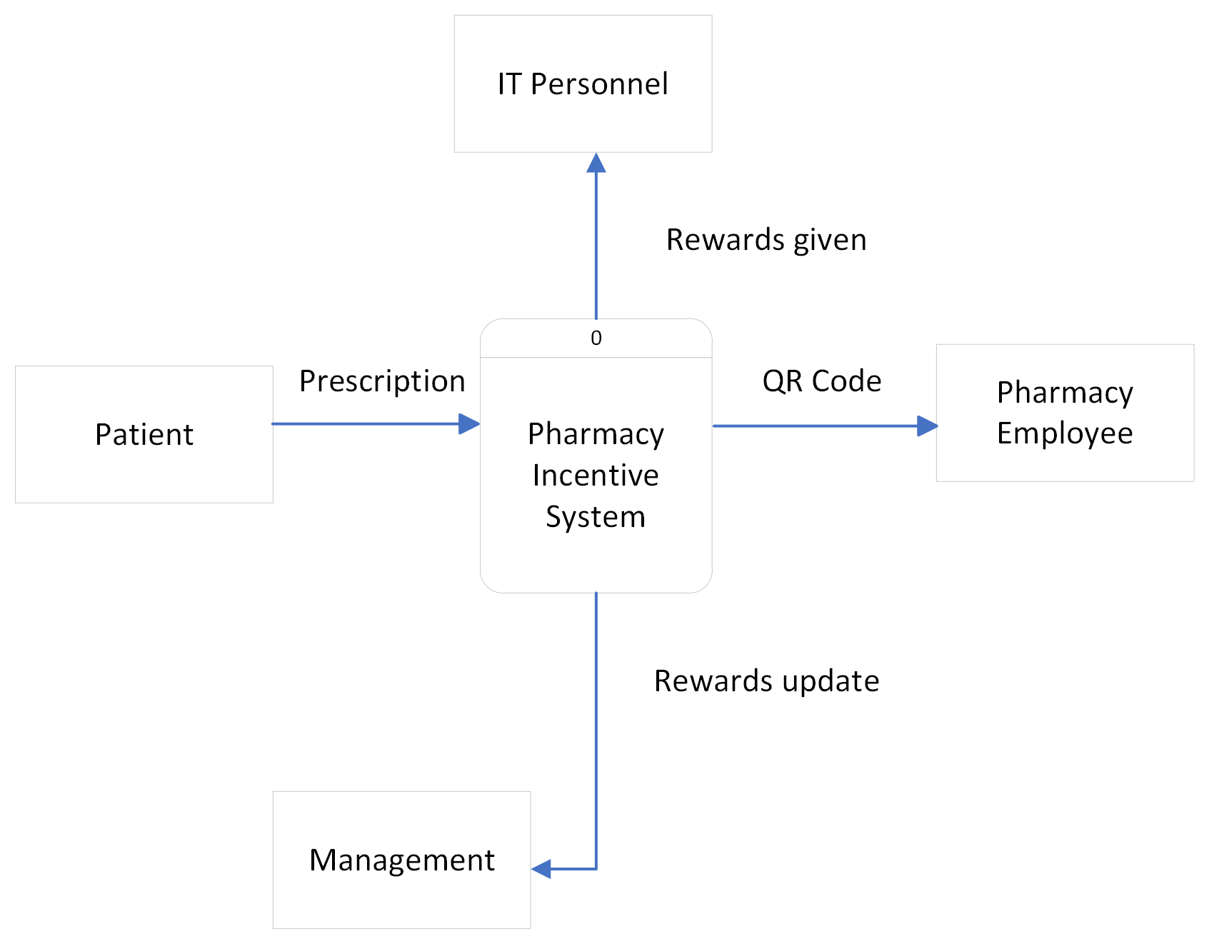

**Figure 1. Concept level diagram**

The concept level diagram describes the data flow between four major external entities in this system.

1. The **patient** brings in the prescription and hands it over to the pharmacy employee.
2. The **pharmacy employee** puts it through the pharmacy incentive system and produces a reward, in the form of a QR code.
3. The information is logged in and updated by **management**.
4. The **IT personnel** receive the updated information to check for bugs and to address major IT issues.

* **Diagram 0**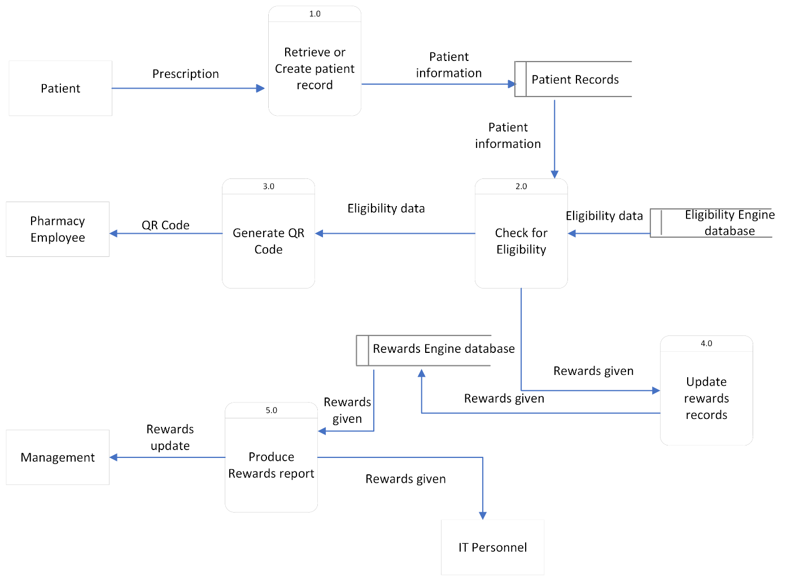

**Figure 2. Diagram 0**

In the diagram above, the pharmacy incentive system is described in greater detail.

* + - **Descriptions of Processes**

The process details:

1. Retrieve or create patient record – This is obtained from the patient records database as the patient brings in a prescription, whether new or refilled.
2. Check for eligibility – The patient information is checked against the eligibility criteria from the eligibility engine database to determine if the patient can receive a reward.
3. Generate QR Code – A QR Code is generated once eligibility is established and passed on to the pharmacy employee.
4. Update Rewards records – The rewards given are stored in the rewards engine database which updates the reward for the patient.
5. Produce rewards report – This process is carried out and sent to management for auditing and IT personnel for tracking of any bugs or IT issues.

**Data Stores**

1. Patient Records
2. Eligibility Engine database
3. Rewards Engine database
   * + **Descriptions of outputs/inputs/performance/security or controls**

The output, which is the reward, will be based on the number of prescriptions (input) brought in by the patient.

**Performance**: This will be based on the number of transactions the system is able to process in a period, i.e., the transaction rate. The database shall be able to process at a level that supports the average number of transactions per second. The Web application UI page shall be able to load and be displayed to users within two seconds. All communications to the database shall not exceed two seconds.

**Security**:

1. To secure the application API, token authentication will be used between the web application and the backend service.
2. SSL certificates will be installed on the pharmacy systems to secure communication with the eligibility service, using encryption in data transmission. Also, two-factor authentication will be used as an additional layer of defense.
3. API management subscription keys will be employed, to allow the microservices to talk to each other.
4. Web application users will provide authentication into the application with a username, password, and OTP codes.

# Phase 2. System and Database Design

The goals of a well-designed system are to be reliable, effective, and maintainable (Tilley, 2016). The proposed incentive system is designed to capture all these elements while providing ease of use for the patients and the pharmacy employees. This system will be integrated with the pharmacy management system that already exists, so the goal is to make this system user friendly and simple enough for the target users.

## User Interface

The user interface is a very important part of the system design and has continued to evolve over time, so the technology will need to be revisited periodically. The mobile application for the proposed system will run on major browsers like Google chrome, Windows Edge, Safari, Firefox, Opera; and PC and mobile platforms such as iOS and android operating systems.

The diagram below shows the sample interface that the patient will see at the login phase. After the patient enters the username and password, the dashboard will be revealed, to show the rewards gained. The transaction history will show the former rewards that have been debited from the account. This interface is designed to be clean and easy to use, so the patient can easily navigate through the available options.

Figure 3. User Interface Design

## Data Design

* 1. **Database Design**
  2. **Entity Relationship diagrams**

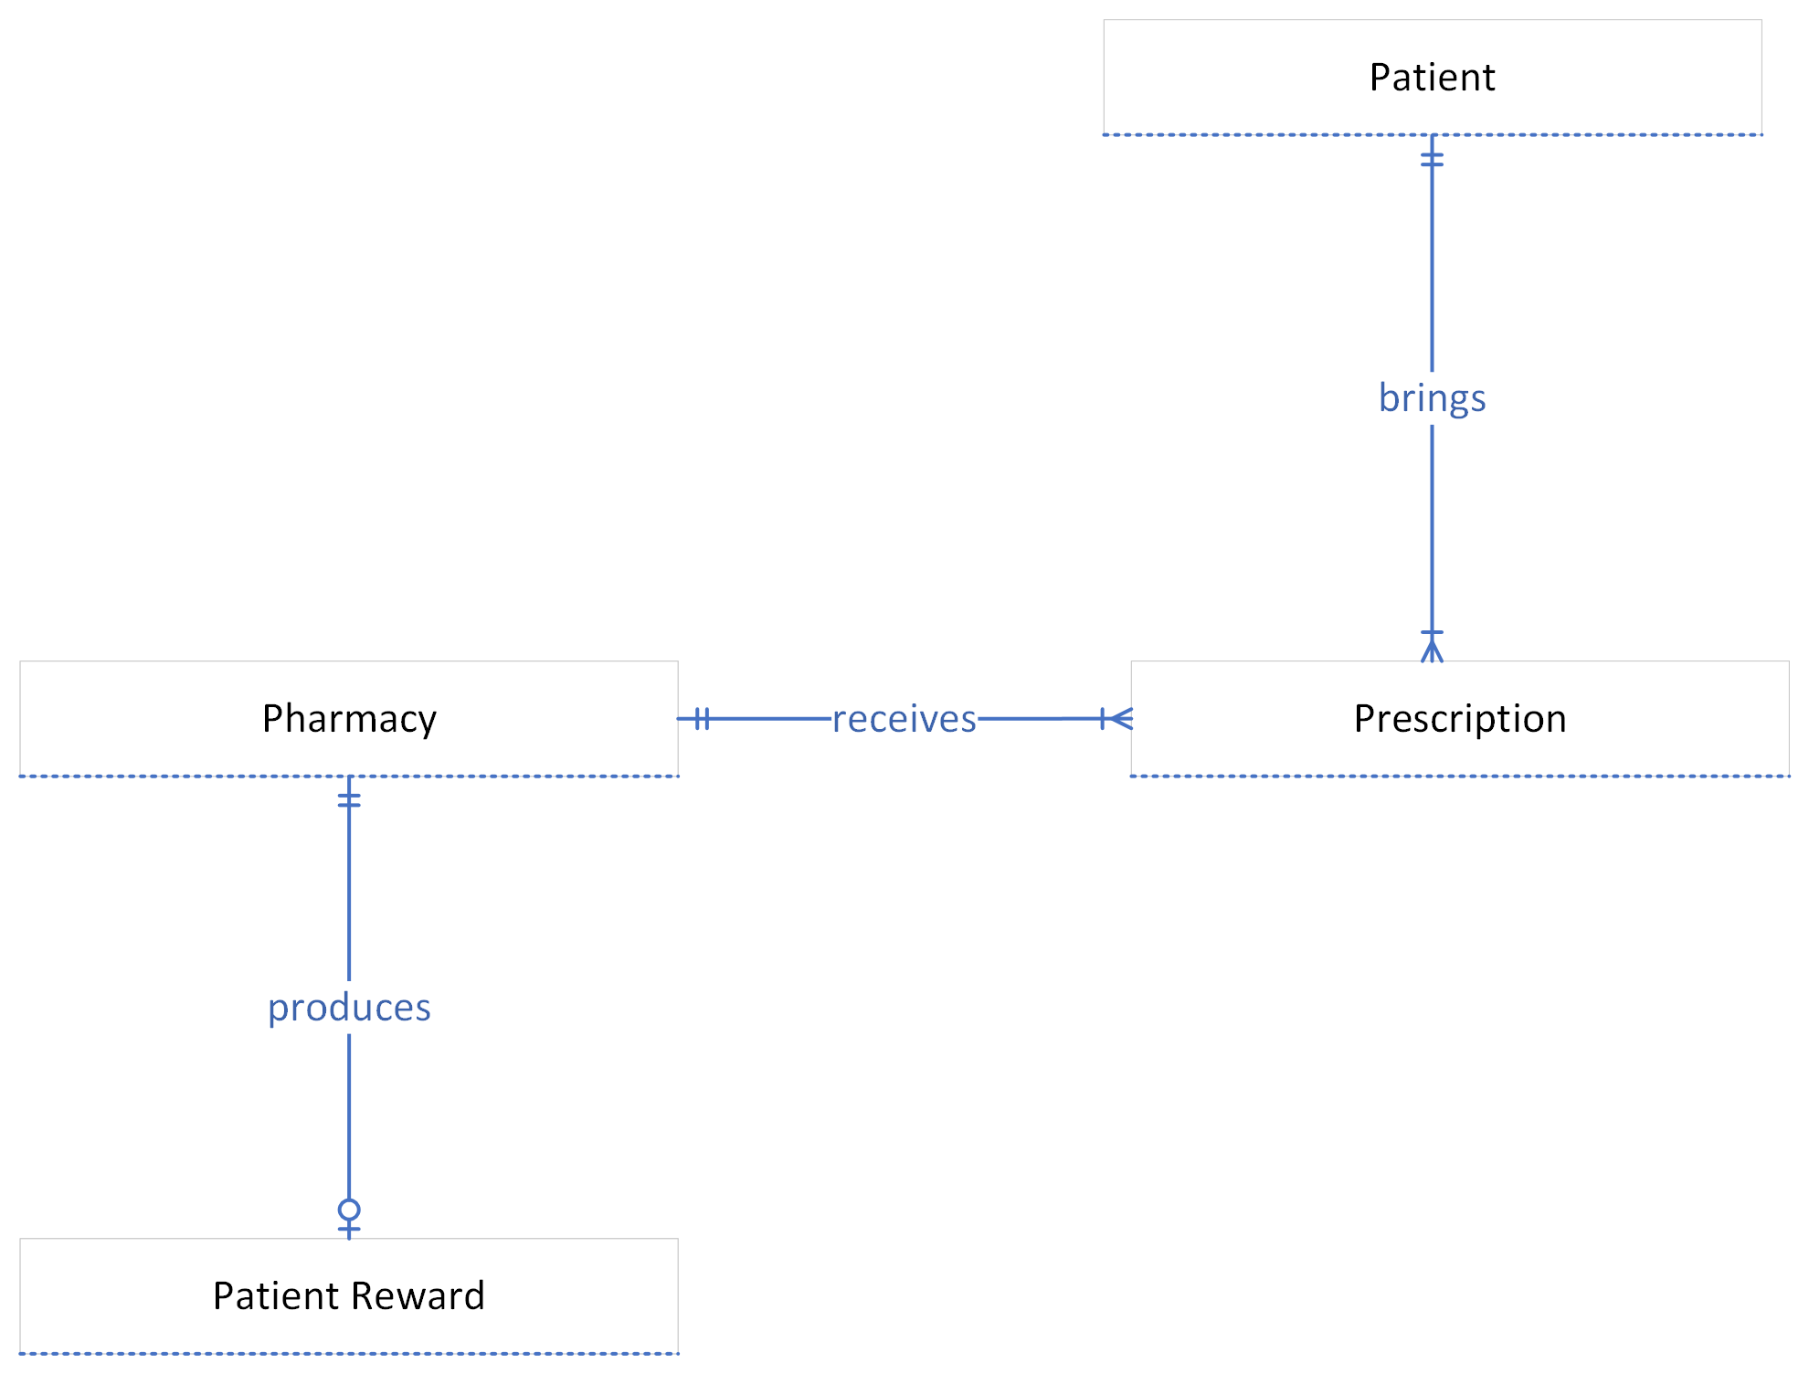 **Figure 4. Basic Entity Relationship diagram**

**Database Tables**

**1NF normalization**

Figure 5. 1NF database tables

The tables are currently in 1NF normalization as there are no repeating groups within the tables. However, some non-key fields such as pharmacy attributes are not wholly dependent on the primary key.

**2NF Normalization**

Figure 5. 2NF Database table

In the 2NF figure, the pharmacy attributes are transformed to a new table with pharmacy ID re-named as the primary key.

**3NF**

Figure 6. 3NF Database tables

The 3NF figure contains an extra entity titled reward-details, fields that are not wholly dependent on the patient rewards field. These are independent of the rewards specific to the patient, so they can dwell on their own. This final figure contains no repeating groups, and the fields are wholly dependent on their individual primary keys.

## System Architecture

The proposed incentive system is based on the microservices architecture, which means that the application consists of a set of various services. Each service will communicate directly with the database, so they can be independently managed, and deployment can be fast and reliable.

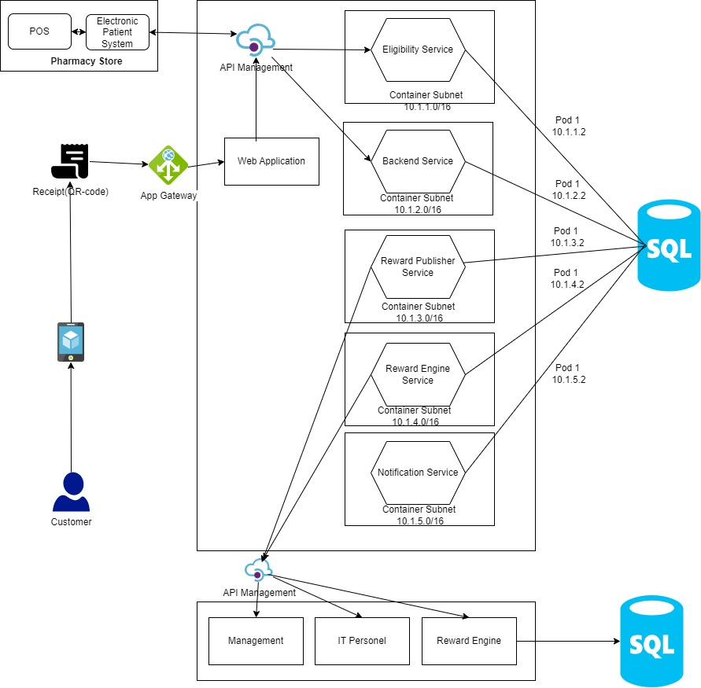

Figure 7. System Architecture

In the figure above, the patient scans the QR Code with their mobile phone, and the web application is deployed, through the API. There are five distinct microservices that cover the incentive system. The eligibility service, backend service, reward publisher, the reward engine and the notification service.

The other entities such as management and IT personnel can access the system through the API, to receive the rewards updates and perform maintenance if necessary.

## Phase 3. Project Plan

1. **Project Timeline**

The table below shows the estimated time frame for the development of the pharmacy incentive program. The estimated total time is about 96 days, and this timeline considers the different phases of the software development process, as well as deployment.

|  |  |  |  |  |
| --- | --- | --- | --- | --- |
| Task Mode | Task Name | Duration | Start | Finish |
| **Auto Scheduled** | **Pharmacy Incentive program** | **95.75 days** | **Mon 5/1/23** | **Mon 9/11/23** |
| **Auto Scheduled** | **Scope** | **3.5 days** | **Mon 5/1/23** | **Thu 5/4/23** |
| **Auto Scheduled** | **Analysis/Software Requirements** | **14 days** | **Thu 5/4/23** | **Wed 5/24/23** |
| **Auto Scheduled** | **Design** | **14.5 days** | **Wed 5/24/23** | **Tue 6/13/23** |
| **Auto Scheduled** | **Development** | **21.75 days** | **Wed 6/14/23** | **Thu 7/13/23** |
| **Auto Scheduled** | **Testing** | **48.75 days** | **Wed 6/14/23** | **Mon 8/21/23** |
| **Auto Scheduled** | **Training** | **45.75 days** | **Wed 6/14/23** | **Wed 8/16/23** |
| **Auto Scheduled** | **Documentation** | **30.5 days** | **Wed 6/14/23** | **Wed 7/26/23** |
| **Auto Scheduled** | **Soft launch** | **70.25 days** | **Wed 5/24/23** | **Wed 8/30/23** |
| **Auto Scheduled** | **Deployment** | **5 days** | **Wed 8/30/23** | **Wed 9/6/23** |
| **Auto Scheduled** | **Post Implementation Review** | **3 days** | **Wed 9/6/23** | **Mon 9/11/23** |
| Auto Scheduled | Software development template complete | 0 days | Mon 9/11/23 | Mon 9/11/23 |

**Table 1. Pharmacy Incentive program timeline**

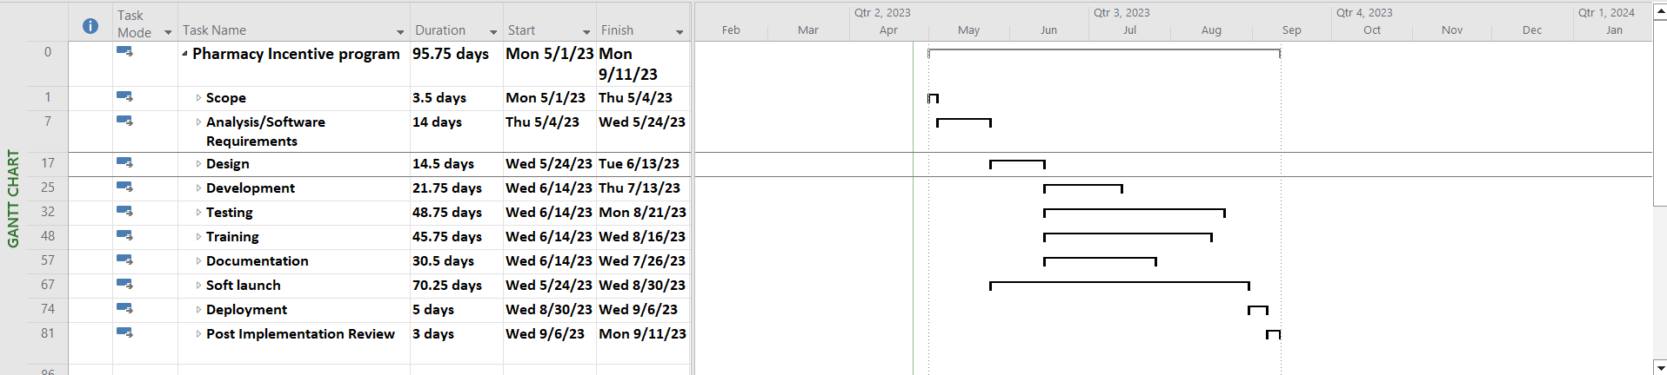

Figure 8. Gantt Chart

Figure 9. Snapshot

This figure shows a snapshot of the subsets under the soft launch tab. The testing, installation and user feedback are all highlighted under this tab, to show the progression using the Microsoft Project tool.

Gantt Chart Timeline

Start  
Mon 5/1/23

Finish  
Mon 9/11/23

May '23

Jun '23

Jul '23

Aug '23

Sep '23

**Scope**  
Mon 5/1/23 - Thu 5/4/23

**Analysis/Software Requirements**  
Thu 5/4/23 - Wed 5/24/23

**Design**  
Wed 5/24/23 - Tue 6/13/23

**Development**  
Wed 6/14/23 - Thu 7/13/23

**Testing**  
Wed 6/14/23 - Mon 8/21/23

**Training**  
Wed 6/14/23 - Wed 8/16/23

**Documentation**  
Wed 6/14/23 - Wed 7/26/23

**Soft launch**  
Wed 5/24/23 - Wed 8/30/23

**Deployment**  
Wed 8/30/23 - Wed 9/6/23

**Post Implementation Review**  
Wed 9/6/23 - Mon 9/11/23

✔Software development template complete  
Mon 9/11/23

Figure 10. Gantt Chart Timeline

1. **Project Budget**

|  |  |  |  |  |  |  |  |
| --- | --- | --- | --- | --- | --- | --- | --- |
| Task Name | Fixed Cost | Fixed Cost Accrual | Total Cost | Baseline | Variance | Actual | Remaining |
| **Pharmacy Incentive program** | **$0.00** | **Prorated** | **$207,278.08** | **$0.00** | **$207,278.08** | **$158,550.15** | **$48,727.93** |
|  |  |  |  |  |  |  |  |
|  |  |  |  |  |  |  |  |
| **Hardware/Maintenance** | **$150,000.00** | **Prorated** | **$150,000.00** | **$0.00** | **$150,000.00** | **$150,000.00** | **$0.00** |
| **Post Implementation Review** | **$0.00** | **Prorated** | **$944.64** | **$0.00** | **$944.64** | **$9.45** | **$935.19** |
| **Deployment** | **$0.00** | **Prorated** | **$1,680.00** | **$0.00** | **$1,680.00** | **$50.40** | **$1,629.60** |
| **Soft launch** | **$0.00** | **Prorated** | **$2,666.88** | **$0.00** | **$2,666.88** | **$113.36** | **$2,553.52** |
| **Documentation** | **$0.00** | **Prorated** | **$11,088.00** | **$0.00** | **$11,088.00** | **$2,439.36** | **$8,648.64** |
| **Training** | **$0.00** | **Prorated** | **$7,936.00** | **$0.00** | **$7,936.00** | **$1,349.12** | **$6,586.88** |
| **Testing** | **$0.00** | **Prorated** | **$9,486.40** | **$0.00** | **$9,486.40** | **$1,707.55** | **$7,778.85** |
| **Development** | **$0.00** | **Prorated** | **$13,836.24** | **$0.00** | **$13,836.24** | **$2,352.16** | **$11,484.08** |
| **Design** | **$0.00** | **Prorated** | **$4,347.28** | **$0.00** | **$4,347.28** | **$250.56** | **$4,096.72** |
| **Analysis/Software Requirements** | **$0.00** | **Prorated** | **$3,885.52** | **$0.00** | **$3,885.52** | **$241.92** | **$3,643.60** |
| **Scope** | **$0.00** | **Prorated** | **$1,407.12** | **$0.00** | **$1,407.12** | **$36.28** | **$1,370.84** |

Figure 10. Project Estimated Costs.

The project budget is estimated at $207,278.08, considering the industry standards for material, hardware, software and labor costs for the software development life cycle.

# References

Bureau of Labor Statistics, U.S. Department of Labor, *Occupational Outlook Handbook*, Software Developers, Quality Assurance Analysts, and Testers. Accessed March 16, 2023. <https://www.bls.gov/ooh/computer-and-information-technology/software-developers.htm>

Force, J. T. (2017). *Security and privacy controls for information systems and organizations* (No. NIST Special Publication (SP) 800-53 Rev. 5 (Draft)). National Institute of Standards and Technology.

Garbaro, D. (2022, October 15). *How the Rx Factor in retail loyalty is evolving.* DrugstoreNews. https://drugstorenews.com/how-rx-factor-retail-loyalty-evolving

Kang, J., Alejandro, T. B., & Groza, M. D. (2015). Customer–company identification and the effectiveness of loyalty programs. *Journal of Business Research*, *68*(2), 464-471.

Patak, M., Lostakova, H., Curdova, M., & Vlckova, V. (2014). The e-pharmacy customer segmentation based on the perceived importance of the retention support tools. *Procedia-Social and Behavioral Sciences*, *150*, 552-562.

Reinert, C. D., & Murray, J. A. (2017). Successful implementation of pharmacy retail store loyalty reward programs. *International Journal of Applied Management and Technology*, *16*(1), 8.

Rewriting the script: independent pharmacy trends. Prescryptive Health. 2022. Accessed April 19, 2023.<https://prescryptive.com/2022-pharmacy-study/>

Tilley, S. (2016). *Systems analysis and design*. Cengage Learning.